**Criação Contrato:**

1. RECN - Process Contract  
   
2. Contrato disponível para aprovação no MyInbox:  
   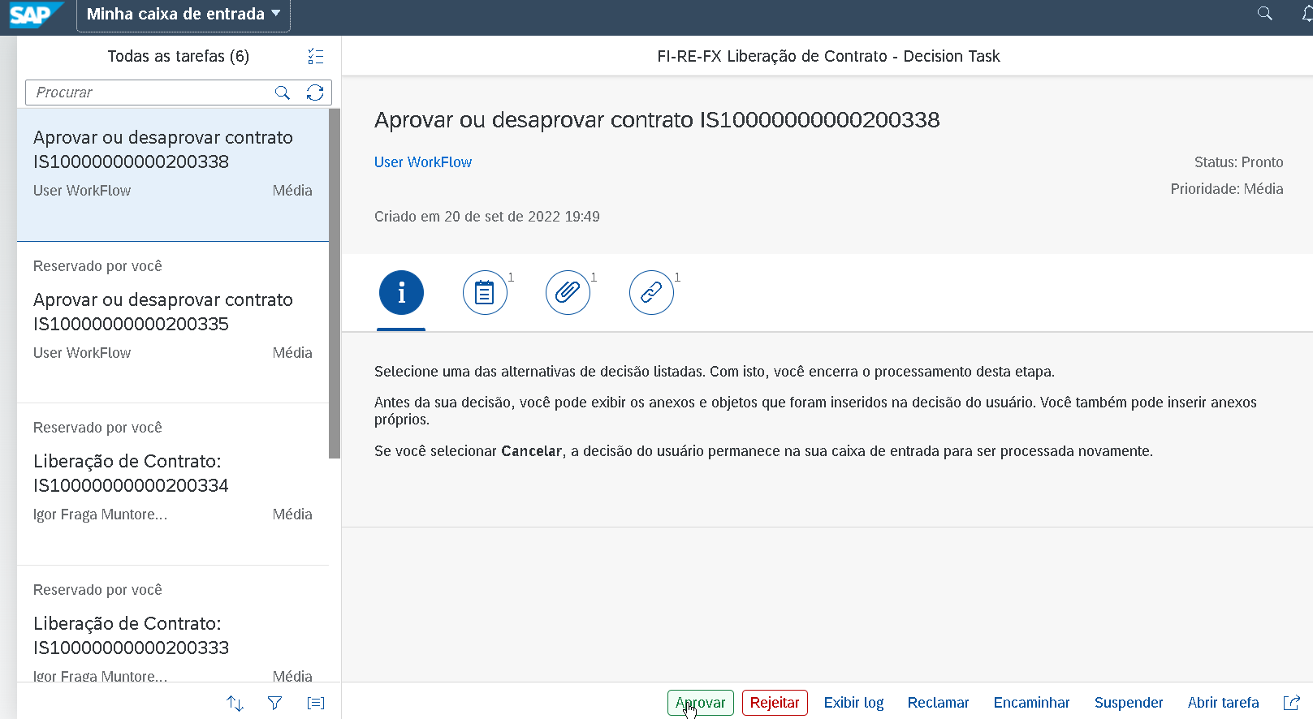
3. Aprovar  
   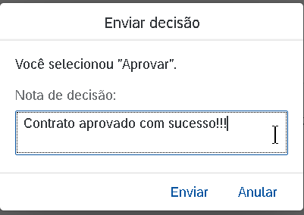
   1. Elemento é removido do MyInbox e transferido automaticamente para o MyOutbox
4. MyOutbox App

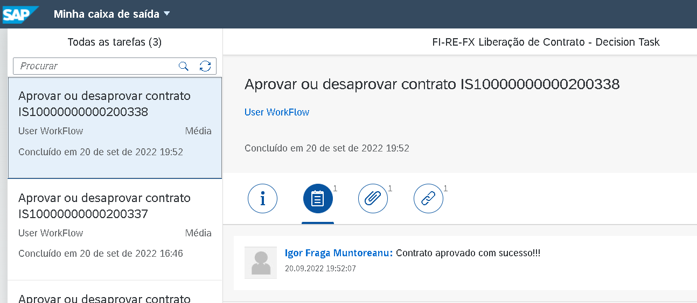

1. SWIA – Trace de Workflow  
   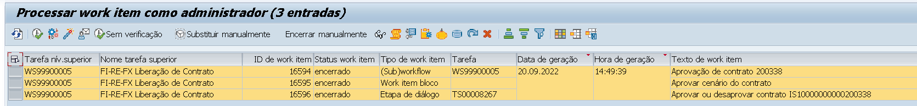

Notas Técnicas:

* Workflow Template: WS99900005
  + ID saída Resultados do Workflow foi modificado:  
    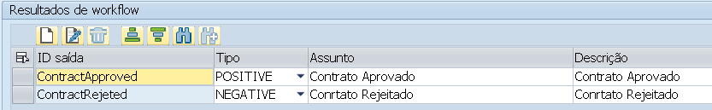
  + Nova atividade criada – Decision Task **Standard** TS000008267  
    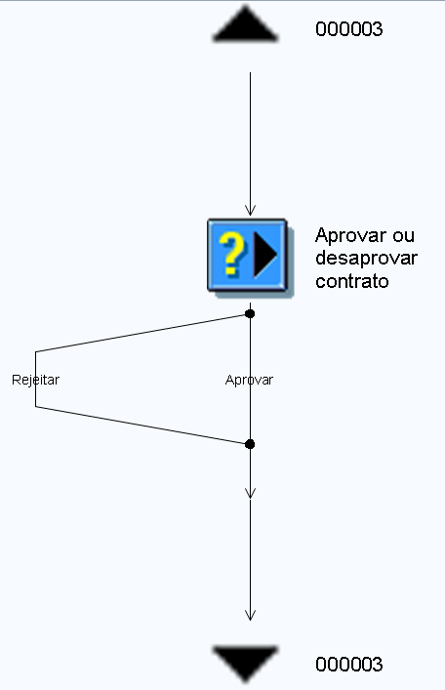  
    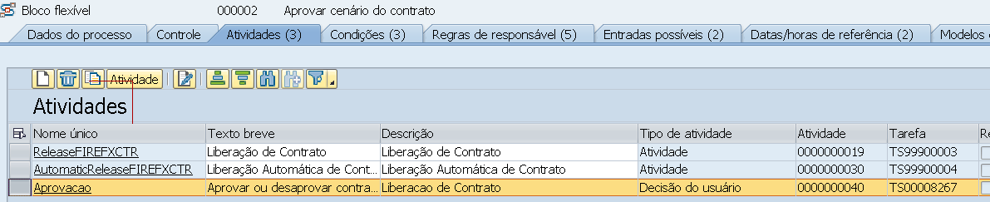

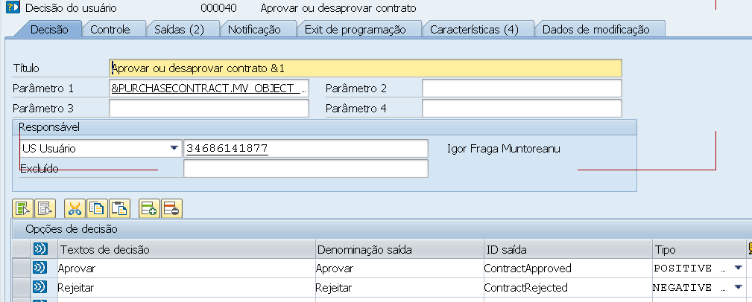

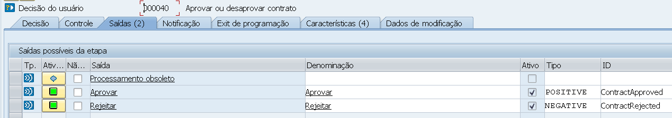

* + Regras de Responsável
    - Aqui criei regra direto para meu User:  
      
  + Ajuste na classe/método
    - ZCL_FI_REFX_CTR_FLEX_WFL~IF_SWF_FLEX_IFS_RUN_APPL~RESULT_CALLBACK
      * Basicamente, pulo toda a atual lógica.
* Configuração SPRO:  
  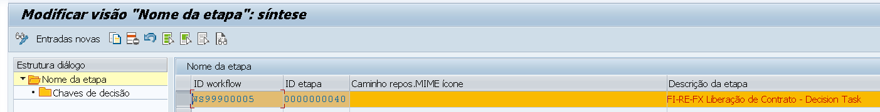

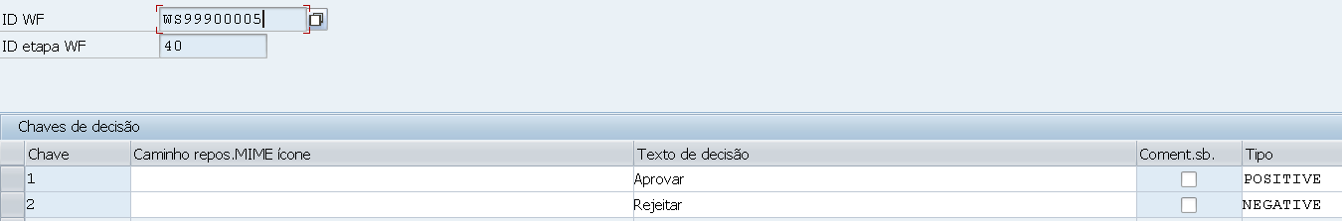

* Administração Workflow
  + Nova Entrada foi criada  
    

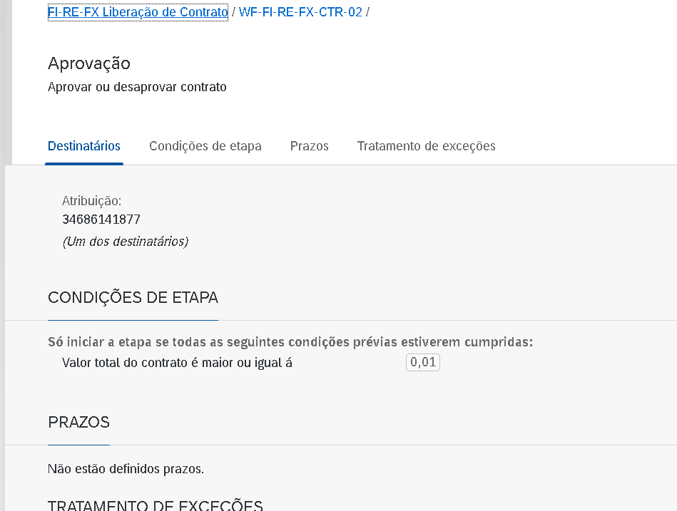

_______________

Objectos:  
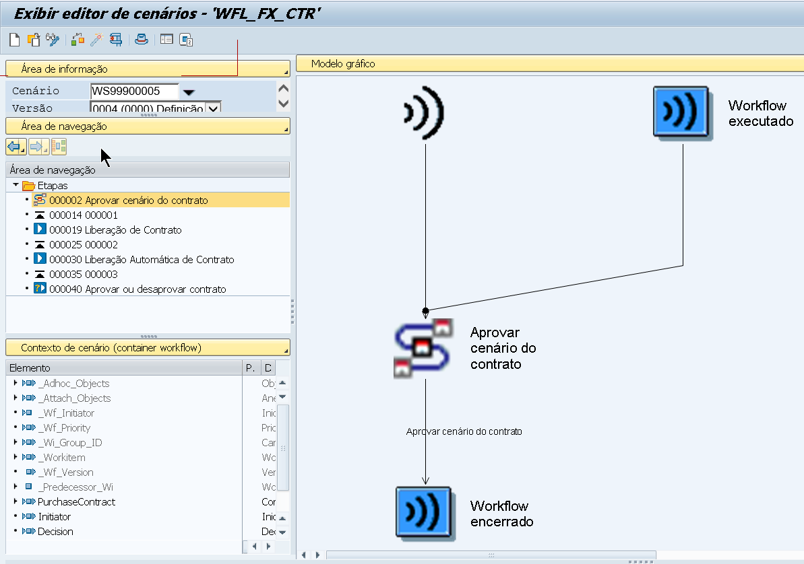

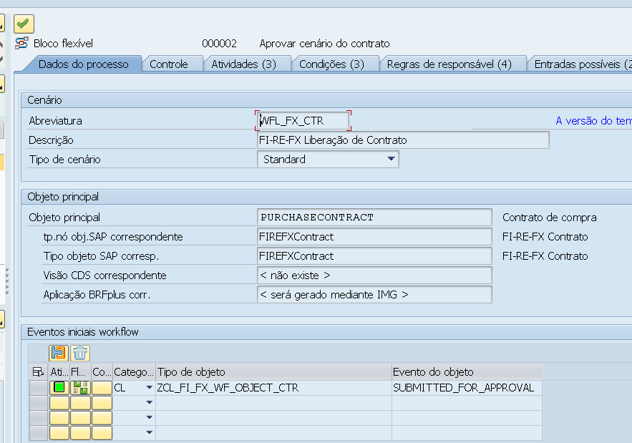

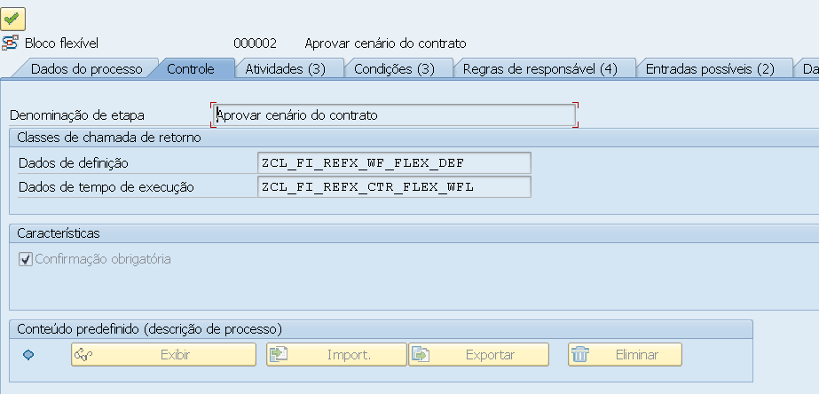

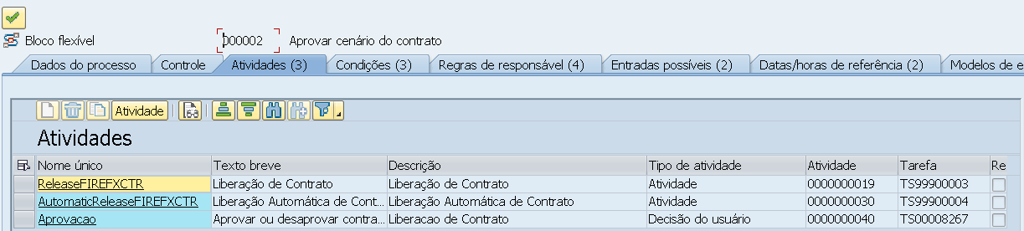

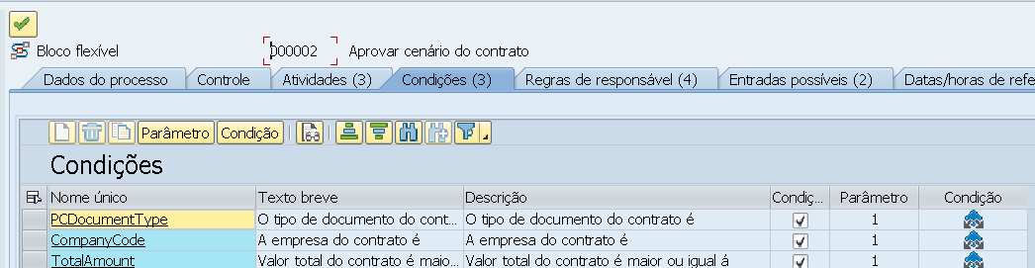

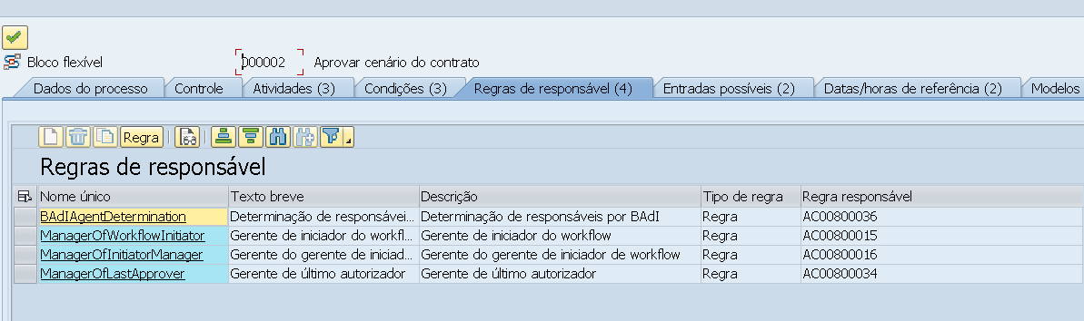

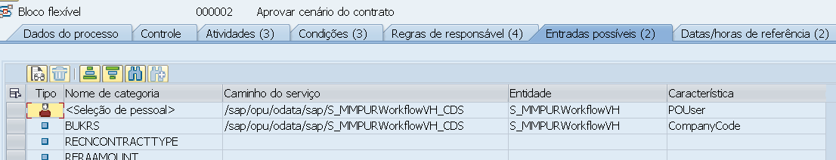

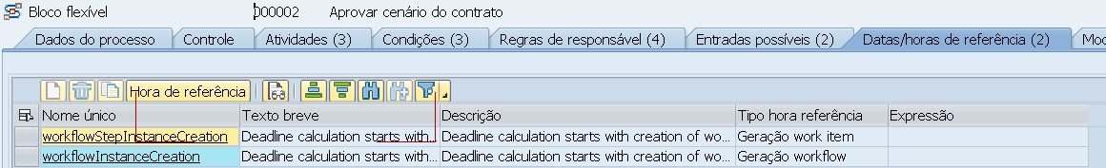

BADI to start workflow

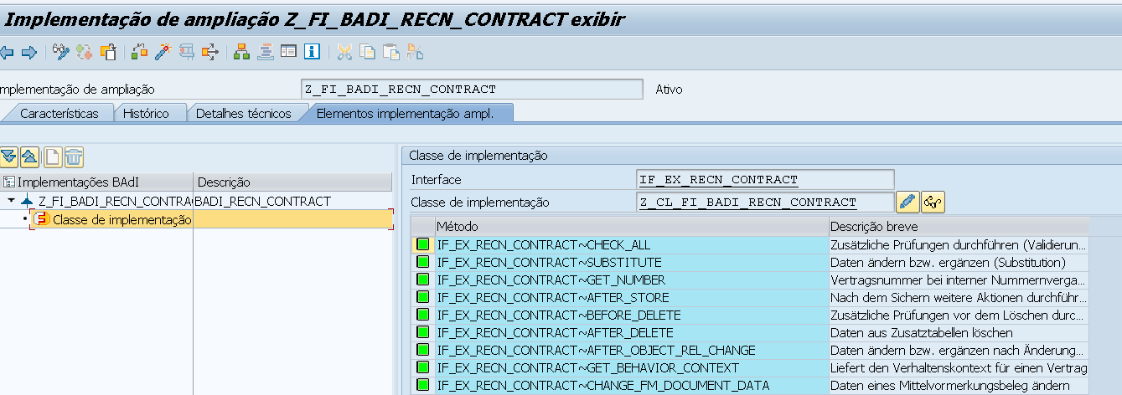

|  |
| --- |
| METHOD if_ex_recn_contract~after_store .    DATA: lo_contract            TYPE REF TO cl_recn_contract.    DATA: ls_recn_contract TYPE recn_contract,         lt_status        TYPE TABLE OF jstat,         ls_status        TYPE jstat,         lt_return        TYPE TABLE OF bapiret2.    DATA: iv_object_id           TYPE recaobjnr.   DATA: iv_bukrs               TYPE bukrs.   DATA: iv_recnnr              TYPE recnnumber.    DATA: iv_objtype             TYPE sibftypeid.   DATA: iv_event               TYPE sibfevent.   DATA: iv_objkey              TYPE sibfinstid.   DATA: iv_initiator           TYPE xubname.    lo_contract ?= io_object.    CHECK lo_contract IS BOUND AND NOT sy-uname = 'SAP_WFRT'. "Do not perform when approving via Workflow    IF lo_contract->md_activity EQ '02'.     ls_recn_contract   = lo_contract->if_recn_contract~ms_detail.      ls_status-inact = space.     ls_status-stat  = 'I0065'. "Block Contract     APPEND ls_status TO lt_status.      CALL FUNCTION 'STATUS_CHANGE_INTERN'       EXPORTING         objnr               = ls_recn_contract-objnr       TABLES         status              = lt_status       EXCEPTIONS         object_not_found    = 1         status_inconsistent = 2         status_not_allowed  = 3         OTHERS              = 4.     IF sy-subrc <> 0.       MESSAGE 'Erro ao bloquear contrato' TYPE 'I'.     ENDIF.    ENDIF.    CHECK lo_contract->md_activity EQ '02'.   " Start Workflow only for Changed Contracts   iv_bukrs           = ls_recn_contract-bukrs.   iv_recnnr          = ls_recn_contract-recnnr.   iv_initiator       = sy-uname.   iv_object_id       = ls_recn_contract-objnr.   iv_objkey          = ls_recn_contract-objnr.   iv_objtype                 = 'ZCL_FI_FX_WF_OBJECT_CTR'.   iv_event                   = 'SUBMITTED_FOR_APPROVAL'.    DATA(lr_event_parameters) = cl_swf_evt_event=>get_event_container( im_objcateg = cl_swf_evt_event=>mc_objcateg_cl                                                                      im_objtype  = iv_objtype                                                                      im_event    = iv_event ).   TRY.       lr_event_parameters->set( EXPORTING name       =  'IV_INITIATOR'                                           value      =  iv_initiator ).        lr_event_parameters->set( EXPORTING name       =  'IV_OBJECT_ID'                                           value      =  iv_object_id ).      CATCH cx_swf_cnt_cont_access_denied. " Changed Access Not Allowed     CATCH cx_swf_cnt_elem_access_denied. " Value/Unit Must Not Be Changed     CATCH cx_swf_cnt_elem_not_found.     " Element Not in the Container     CATCH cx_swf_cnt_elem_type_conflict. " Type Conflict Between Value and Current Parameter     CATCH cx_swf_cnt_unit_type_conflict. " Type Conflict Between Unit and Current Parameter     CATCH cx_swf_cnt_elem_def_invalid.   " Element Definition Is Invalid (Internal Error)     CATCH cx_swf_cnt_container.          " Exception in the Container Service   ENDTRY.    TRY.       CALL METHOD cl_swf_evt_event=>raise         EXPORTING           im_objcateg        = cl_swf_evt_event=>mc_objcateg_cl           im_objtype         = iv_objtype           im_event           = iv_event           im_objkey          = iv_objkey           im_event_container = lr_event_parameters.     CATCH cx_swf_evt_invalid_objtype .     CATCH cx_swf_evt_invalid_event .   ENDTRY.  ENDMETHOD. |

ZCL_FI_REFX_CTR_FLEX_WFL

|  |
| --- |
| METHOD if_swf_flex_ifs_run_appl~result_callback.    DATA ls_por TYPE sibflpor.   DATA lt_return TYPE TABLE OF bapiret2.    DATA(ls_result) = io_result->get_result( ).   MOVE-CORRESPONDING io_context->get_leading_object_reference( ) TO ls_por.   IF ls_result-result = 'ContractApproved'.      CALL FUNCTION 'BAPI_RE_CN_CHANGE'       EXPORTING         compcode       = ls_por-instid+2(4) "Bukrs         contractnumber = ls_por-instid+6(13) "Contract         trans          = 'PSEM' "UnLock Master Data "Release = PSEM       TABLES         return         = lt_return.    ELSEIF ls_result-result = 'ContractRejeted'.     "Do nothing. remains locked   ENDIF.  ENDMETHOD. |